**The Tragedy of Flight: A Comprehensive Crash** **Analysis**

**Project Report**

1. Introduction
   1. Overview

The goal of an airplane crash analysis is to identify any factors that contributed to the accident, with the ultimate goal of improving safety and preventing future accidents.

* 1. Purpose

The objective of accident analysis is to prevent accidents in the future. This statement is not as trivial as it looks: to many the objective is to identify those who were responsible, or simply to fulfil a legal or organisational requirement.

2. Problem definition & Design thinking

2.1 Empathy Map

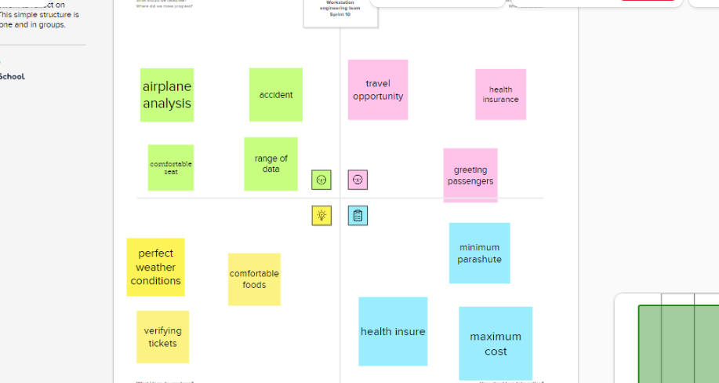

2.2 Ideation & Brainstorming Map

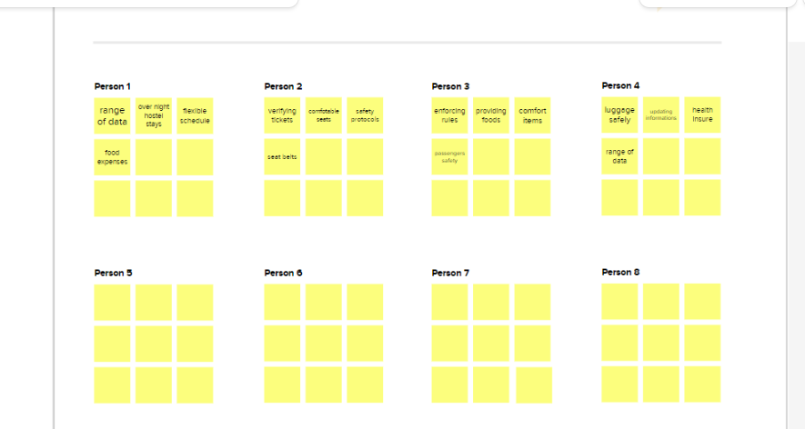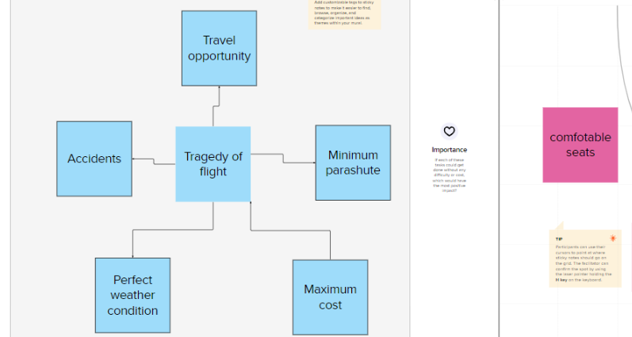

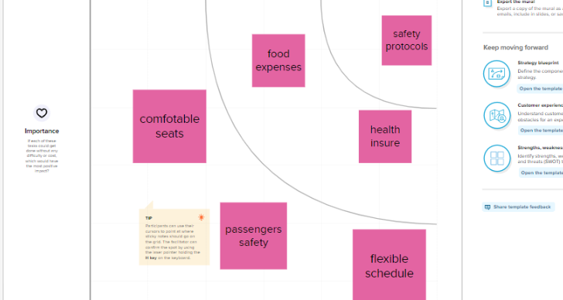

3 Result

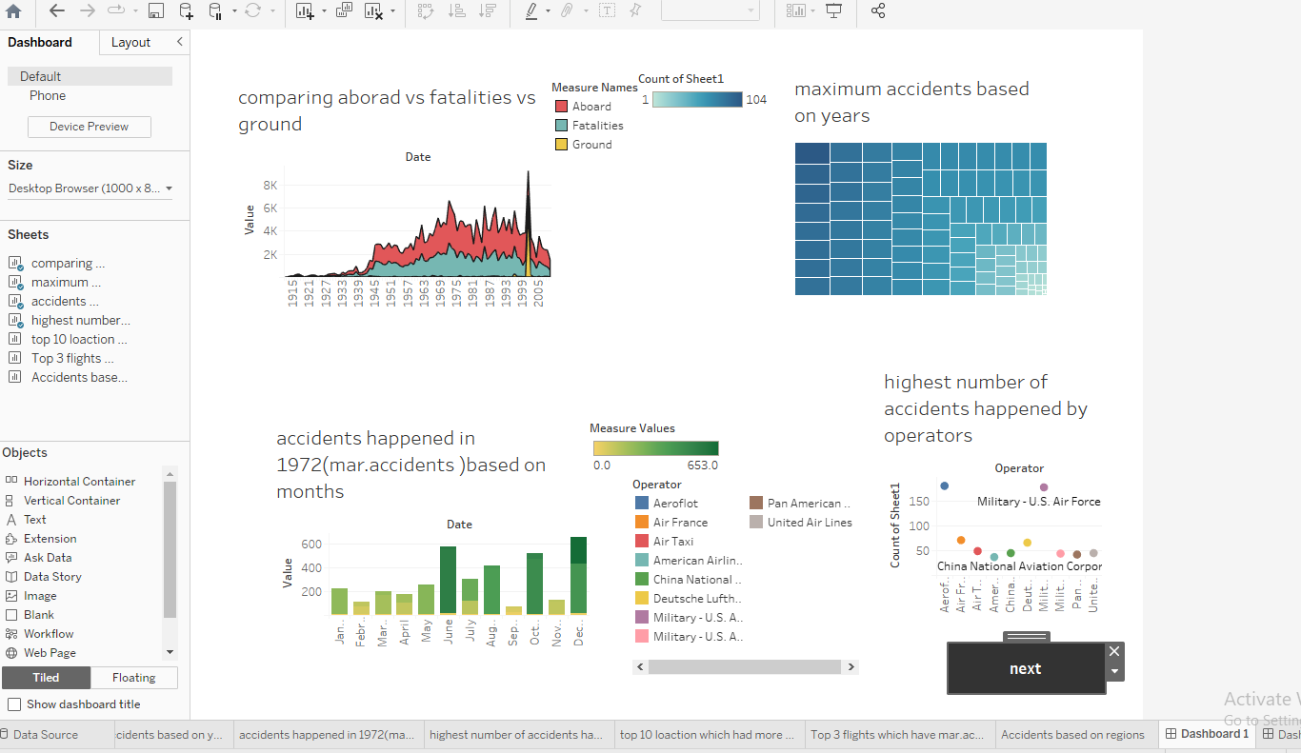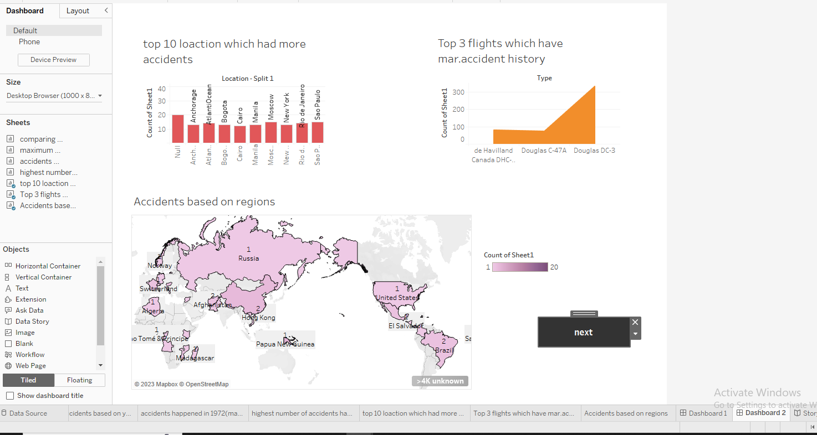

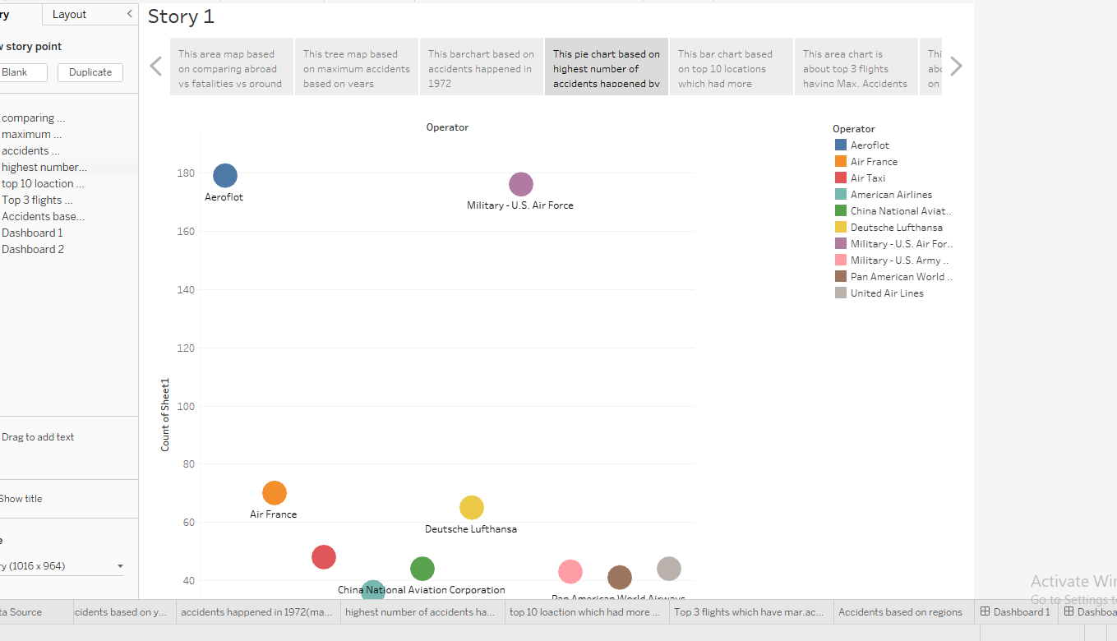

4. Advantages & Disadvantages

Advantages

* Fastest mode of transport.
* Cheaper infrastructure.
* Air travel is strategically significant.
* Free from geographic barriers like hills and lakes.
* Useful during natural disasters.

Disadvantages

* High operational costs.
* Air transport accidents are usually fatal.
* Huge initial investments.
* Difficult to carry very large cargo.
* Affected by bad weather.

5. Applications

To effectively discover the hazards that led to the accident and to prevent their recurrence in a future accident or incident.

6. Conclusion

Our explanation has by its very nature been objective and procedural in tone. We have not spoken about the consequences for the next of kin. At the same time we are aware that what we have discussed here will not have left the next of kin unaffected.

7. Future Scope

The most recent estimates suggest that demand for air transport will increase by an average of 4.3% per annum over the next 20 years. If this growth path is achieved by 2036 the air transport industry will then contribute 15.5 million in direct jobs and $ 1.5 trillion of GDP to the world economy.

8. Appendix

A. Source code: R.Gayathri team final project.html